In caAERS, you can add subjects by filling in pages of information, which is described in this topic, or you can contact your caAERS administrator to import an XML file comprising the subject's information. If you are using caAERS as part of the Clinical Trials Suite (CCTS), this process is transparent and when a participant is registered in a study in caBIG Clinical Participant Registry (C3PR) the subject is added automatically to caAERS. Once the subject is added to caAERS, you can search for a subject, edit the subject's information, and assign a subject to a study.
Note: All fields in caAERS that have a red asterisk next to them means that you must complete the field to save and continue to the next page. Based on the user role assigned to you by the caAERS administrator, you may not have access to all the fields and pages described in this topic.

Contents
[hide]
- 1 Updating a Broadcasted Subject from C3PR - caBIG Clinical Trials Suite Users Only
- 2 Adding a New Subject
  - 2.1 Adding Subject Details
  - 2.2 Associating a Study with the Subject
  - 2.3 Entering Subject Medical History
  - 2.4 Reviewing the Subject Information
- 3 Searching for a Subject
- 4 Reviewing and Editing Subject Details
- 5 Assigning a Subject to a Study

Updating a Broadcasted Subject from C3PR - caBIG Clinical Trials Suite Users Only
If you received an alert on the Comments/Alerts tab that a new subject was added from another Suite application, you can update the subject with caAERS information. For important information about adding subjects to The Suite, see caBIG Clinical Trials Suite User's Guide, Chapter 6.

Adding a New Subject
To access the Details page and start adding a subject
- Click the Subjects tab in the navigation bar.
- Click Enter Subject. The Details page opens.

Adding Subject Details
On the Details page (see Adding a New Subject and follow the procedure to display this page), you can associate an organization and demographic information with the subject along with two different types of identifiers:
- System identifiers enable users of other applications to find the subject because the application's ID for the subject is entered here.
- Organization identifiers enable users from associated sites to find the subject because the organization's ID for the subject is entered here.
This creates a map of IDs so that different users in different areas can find the same subject using different IDs.
To add subject details
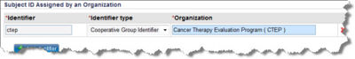
- Select an Organization that is the study site for the subject. These are limited to the sites to which you have access.
- Enter the following information about the subject. Items with asterisks are required.
  - First Name, Middle Name, and Last Name
  - Maiden Name
  - Date of Birth in the format yyyy (year), mm (month), and (dd) day.
  - Gender, Ethnicity, and Race
- Enter the Subject Identifier.
- Add an Organization identifier to the subject:
  - Click Add Identifier.
  - Fill in the Identifier.
  - Specify the Identifier Type:
    - Cooperative Group Identifier is a National Cancer Institute organization that comprises a group of cancer centers, hospitals, community facilities. Each group may have many sites and many subjects that focus on the study of a certain type of cancer. A cooperative group provides a new clinical trial with a single place to go to offer a protocol to a relevant group of sites and subjects.
    - Medical Record Number represents the systematic documentation of a patient's medical history and care
    - Other
  - Specify the Organization that is associated with the identifier. You must enter the entire name or a portion of the name. Even though you may not have an affiliation with all of the organizations available, you can select them and enter an appropriate ID so the organization has access to this information.
- To add another Subject ID, click Add Identifier.
  - To delete a Subject ID, click the x to the right of the row and click Ok.#To add a System identifier to a subject, click Add Identifier.
- To add an identifier assigned by another system:
  - Click Add Identifier.
  - Fill in the Identifier.
  - Specify the Identifier Type:
    - Cooperative Group Identifier
    - Medical Record Number
    - Other
- To add another Organization ID, click Add Identifier.
  - To delete an identifier, click the x to the right of the row and click Ok.
- To save your changes, click Save.
  - To save your changes and return to the previous page, click Save and Back.
  - To save your changes and continue to the Choose Study page, click Save and Continue.

Associating a Study with the Subject
The Choose Study page (see Adding a New Subject and follow the procedure to display this page) enables you to associate one or more studies with the subject.
To associate a study with a subject
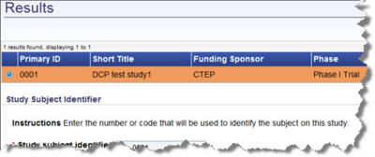

Entering Subject Medical History
On the Medical History page (see Adding a New Subject and follow the procedure to display this page) you define any medical conditions that the subject experienced prior to entering the clinical trial.
To enter medical history information
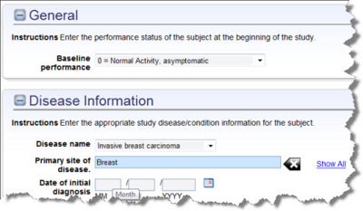
- Select the Baseline performance, an initial measurement taken at an early time point to represent a beginning condition, and is used for comparison over time to look for changes. For example, the size of a tumor will be measured before treatment (baseline) and then afterwards to see if the treatment had an effect.
- Enter the Height and Weight of the subject. You must specify the units in Inches and Pounds OR Centimeters and Kilograms. If you mix the units of measurement, caAERS cannot calculate the body surface area.
- Select the Disease Name. If disease coding terminology other than CTEP or MedDRA was entered for the study chosen for this subject, you can select it from this drop down menu.
- Enter the Primary Site of Disease, the site where the disease started. Enter the first few letters of the primary site or characters within the name and then select the site from the list. You can also click Show All and select it from the list in the pop up window that appears.
- Enter the Date of the Initial Diagnosis in the format mm/dd/yyyy or click the calendar icon and select a date. When you provide the date, the DD field is not required.
- Document metastatic disease sites, the primary site (place where it started) and the other places in the body. Enter the first few letters of the metastatic disease site or characters within the name and then select the site from the list.
  - You can also Show All and select it from the list in the pop up window that appears.
  - To delete a Metastatic Disease Site, click the x to the right of the row, and click Ok.
- Document any pre-existing conditions that might contribute to an event.
  - To add a Pre-existing Condition, a medical condition that existed before the subject started the clinical trial, select the condition from the Pre-Existing Condition list and click Add. The list of pre-existing conditions is based on MedDRA.
  - To delete a Pre-existing Condition, click the x to the right of the row and click Ok.
- Document any Concomitant Medications (conmeds) or medications a person is taking that are not being studied and may have contributed to an adverse event.
  - To add a conmed, enter information about concomitant medication, and click Add.
  - Indicate whether the concomitant medication is still being taken.
  - Enter the date the subject started taking the medication, if known, in the format mm/dd/yyyy or click he calendar icon and select a date.
  - Enter the date the subject stopped taking the medication. Indicate whether it has been discontinued and is known.
  - To delete a conmed, click the x to the right of the row, and click Ok.
- Document any prior therapies for the primary disease. If the information is relevant, enter any prior therapies for non-primary diseases.
  - Select the Prior Therapy and click Add. This list is based on the CTEP Therapy Classification.
  - Enter Comments, if applicable.
  - Enter a Therapy Start Date and End Datein the format mm/dd/yyyy or click the calendar icon and select a date.
  - For prior therapies, an agent is required, medicines, vitamins, minerals, or food supplements. Enter the first few letters of the name and select from the list that appears and click Add.
  - To delete a therapy, click the x to the right of the prior therapy.
- To expand a medical history item, click the + sign. All the information for that item opens.
  - To collapse a medical history item, click the - sign.
- To save our changes, click Save.
  - To save and return to the previous page, click Save and Back.
  - To save and continue to the Review page, click Save and Continue.

Reviewing the Subject Information
Verify the information that you entered is complete. To save your changes, click Save. To return to a previous page click Save and Back.

Searching for a Subject
When you search for a subject, you can fill in one or all fields completely or partially. You can also leave all the fields blank so that all subjects are listed in the results.
To access Search Criteria page for Subjects
- Click the Subjects tab in the navigation bar.
- Click Search Subjects. The Search Criteria page opens.
To search for a subject
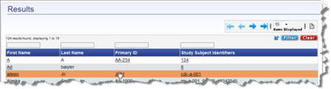
- Enter a Subject identifier. If you leave all of the search criteria blank, all subjects in caAERS display in the Results.
- Enter the First Name and/or Last Name or a portion of the name. For example, if you enter Alex, Alexandra and Alexander will appear in the results.
- Click Search. The Results display on the bottom of the page.
- From the Results page, to find the right subject see Finding a Search Result.
- When you find the subject, click the row and the Review page opens.

Reviewing and Editing Subject Details
To review and edit a subject
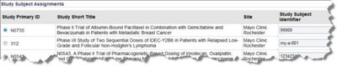
- Search for the subject that you want to edit. See Searching for a Subject. Once you select the subject, the Review page opens.
- To edit the medical history for a certain study that the subject is in, click the button next to the study that you want to edit.
- Review the information, and click Continue. The Details page opens.
- For information about all other fields on the Details page, see Adding Subject Details.
- Save the changes and continue. Click Save and Continue.
- To edit Subject Medical History see Entering Subject Medical History.
- To save your changes, click Save.
- The message You have successfully updated the subject displays at the top of the review page.

Assigning a Subject to a Study
To assign a subject to a study
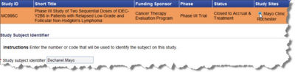
- Click the Subject tab, and click Assign Subject to Study. The Search Criteria page for a subject opens. See Searching for a Subject.
- In the search results, find the subject to be assigned, and click the Primary ID button in the subject's row. This is the subject selected to assign to a study.
- Click Continue at the bottom of the page.
- The Search Criteria page for a study opens. See Searching for a Study.
- In the search results, find the study to which you want the selected subject assigned, and click the Study Sites button.
- At the bottom of the page, assign a the Study Subject Identifier that identifies the subject and study. The subject may be in five studies, so this level of distinction is useful.
  - To save your changes, click Continue.
- The Subject Medical History page opens. See Entering Subject Medical History.
- To save your changes, click Save.
- The message You have successfully updated the subject displays at the top of the review page.

